Vaughn Cemetery

We welcome you to the historic Vaughn Cemetery and trust that you will find this sacred resting place for many of Wood River's early settlers and various war veterans, a scenic and peaceful place to visit amidst its towering mature trees.
This cemetery , once known as the" Vaughn Graveyard" dates back to the early 1800's and was started by the Vaughn family whose family farm once encompassed much of the land that adjoins Highway 111 and whose farmhouse was located in the general vicinity. Within the boundaries of the two acre cemetery there once stood Madison County's first Baptist Church, pastored by the Rev. William M. Jones Sr., whose family is buried here.
The cemetery also honors the veterans who fought to protect personal freedom in the Revolutionary War, the War of 1812, the Civil War and the Mexican American War.
It is the final resting place for the victims of the Wood River Massacre. On July 10, 1814, while walking between two homesteads, a small band of Native Americans killed Rachel Reagan, her two children, two sons of William Moore and two sons of Abel Moore.
Due to their age, numerous headstones have been damaged and some repaired. Sadly, others could not be repaired or could not be reunited with the proper graves and the remains of those headstones are assembled in one location to keep them from being lost or destroyed. The unmarked graves are now marked with a cross as a memorial to those listed below. Based on our gathered information, it appears the first person buried in the cemetery was Sarah Pruitt Jones in 1806 and to date, the last was a descendant of the Vaughn family, Richard Vaughn Husted
in 2019.
We hope you visit the cemetery again and invite family and friends so they can enjoy the serenity and share this piece of local history.
* For more details about the cemetery and Wood River's early settlers, please visit the Wood River Museum and Visitors Center.

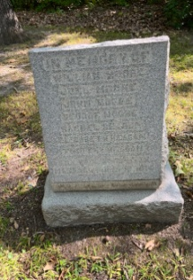
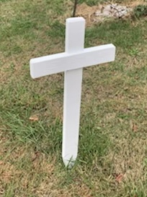
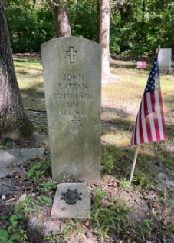
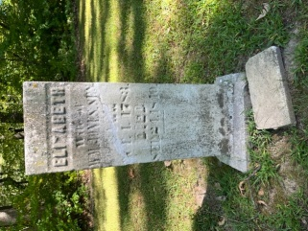

Oldest Headstone Veteran Grave
Elizabeth Jones John Rattan Headstone for Victims of Massacre Cross for Unmarked Graves
1806

*You may call or visit the Wood River Museum and Visitor Center at 40 E. Ferguson in Wood River for more information on where your ancestor's cross is located.

LAST NAMES OF MARKED VETERANS VICTIMS OF THE NAMES OF UNMARKED GRAVES GRAVES WOOD RIVER MASSACRE (MARKED WITH CROSSES)
REVOLUTIONARY WAR
Pvt. John Cornelison
Pvt. Anthony Harrison
John Rattan, Sol. Continental Line

MEXICAN AMERICAN WAR
Pvt. Gilbert Cooper

CIVIL WAR
Pvt. James Fortiner
Pvt. Henry Huntington
Cpl. Henry Lawrence
Pvt. George F. Morgan
Pvt. Thomas O'Neil

WAR OF 1812
Capt. Francis Patrick Berry, Sr. (Unmarked)
Capt. William Jones, Sr.
Pvt. Martin Jones

Lawrence
McGee
Mitchell
Morgan
Owens
Perrott
Powless
Permely
Pruitt
Rattan
Ray
Restemeier
Rotsch
Squires
Starkey
Sullivan
Vaughn
Worthington
Yeager

Matt W. Bratton
Joseph Brown
Charles Bustemeier
Wilbur Campbell
Willie Clawson
John A. Cooper
Anna Diller
Benjamin Flack
Catherine Ellen Flack
John S. Flack
Eliza Glern
E. Lawrence Green
Abe Haller
Eugene Haller
Ida Haller
E. M. Ingall
Adolph Jones
Eula Jones
James Jones
Nancy Jones
Sarah Pruitt Jones
Unk. Jones
Maggie Kendall
Annabelle Lawrence
Benjamin Lawrence
Emily Benson Lawrence
William John Lawrence
Virginia Maltby
Katie Meyers

Christopher Morgan
Christopher R. Morgan
John Morgan
John W. Morgan
James Daniel Odell
William Ogle & Family
John S. Owens
Gaines Owens
Mrs. Pruitt, Mother to Charles
Adolph Ray
Eula Ray
Sarah Smith
Mortimer Martin Squires
Sanford Squires
Jesse Starkey
Mary Starkey
Oilad Starkey
Sara Starkey
William Starkey
Bertha Sutton
Infant Swarringim
Hardin Harry Thompson
Modee Wilson
Daniel Woods
Helen Wuestenfield
Joseph Young

Crosses Donated by:
Ninian Edwards Chapter, NSDAR
Sign by:
City of Wood River
George Moore
Joel Moore
John Moore
William Moore
Elizabeth Reagan
Rachael Reagan
Timothy Reagan

Anderson
Berry
Bratton
Breedlove
Campbell
Copeland
Dolbow
Fentress
Flack
Fortiner
Green
Haller
Henry
Husted
Janssen
Johnson
Jones
Kendall
Kessinger
Largent

Crosses Donated by:
Ninian Edwards Chapter, NSDAR
Sign by: The City of Wood River

